**TECHNICAL DOCUMENTATION**

**INTRODUCTION**

This technical documentation serves as a comprehensive guide for the Sales and Employee Management System designed for Au Water Refilling Station. It provides detailed information to help readers understand, configure, and effectively use the system.

The document is intended for developers, stakeholders, and future researchers who require an in-depth guideline on the system's functionality, structure, and implementation. It presents a clear and concise overview of the system, covering all essential aspects, including installation, configuration, and usage instructions from a user’s perspective.

This documentation offers detailed explanations of key concepts and components, ensuring a thorough understanding of the system's functionality. It includes the database structure, troubleshooting procedures, and strategies for system testing and maintenance to ensure smooth operation and long-term sustainability.

The primary objective of this documentation is to ensure that both technical and non-technical users can easily comprehend and utilize the Sales and Employee Management System with minimal difficulty. By following the guidelines provided, users can efficiently navigate the system, manage sales transactions, monitor employee records, and optimize business operations with accuracy and ease.

Through this document, the development team aim to facilitate seamless implementation and user adoption, providing a reliable resource for understanding and utilizing the system effectively.

**SYSTEM OVERVIEW**

The System Overview is a top-level description of the Sales and Employee Management System for the AU Water Refilling Station. This section fills the gap between technical stakeholders by describing the purpose, scope, and functionalities of the system. It also justifies the entire document by emphasizing the main objectives, system architecture, and the projected impacts of the project.

It is aimed at overcoming specific difficulties at the AU Water Refilling Station by providing effective, user-friendly, and secure systems for operating functions. It has essential elements such as.

1. **User Interface (UI).** It is used for interaction between the system and the users, providing convenience and usability.
2. **Business Logic Layer (BLL).** Manages the business-related functionalities and operational principles of the system.
3. **Data Access Layer (DAL).** Deals with secure and effective storage and retrieval of data.

These layers collaborate to provide a smooth activity flow, optimizing operations and facilitating data-driven decision-making. The System Overview also presents how the system will fit into the business needs of the AU Water Refilling Station. It highlights its use in streamlining workflows, enhancing the accuracy of information, and generally improving decision-making processes.

In giving stakeholders, a proper understanding of the objectives of the system and the benefits it will bring in addressing current problems, this section provides a clear and orderly presentation.

**Architectural Goals**

The Architectural Goals and Constraints specify the major objectives and restrictions that determine the design and implementation of the Computerized Management System for the AU Water Refilling Station. These factors guarantee the system's adequacy to meet the business operation requirements while respecting technical, financial, and resource restrictions.

1. **Efficiency and Performance**

The system should process data and operations with low latencies in order to enable real-time decision-making and smooth operations.

1. **Scalability**  
   The architecture should accommodate future growth in terms of users, data volume, and additional features without significant rework.
2. **Security**  
   Adopt strong security practices to safeguard sensitive customer and business information against unauthorized viewing, breaches, and weaknesses.
3. **User**-**Friendly** **Interface**

Create an easy-to-use and intuitive User Interface (UI) to ease both technical and non-technical users into tasks, facilitating effortless adoption throughout the organization.

**Constraints**

**Budgetary Constraints**

1. The system must be developed and maintained within the allocated financial resources.
2. Expensive technologies, software, or infrastructure that exceeds the budget should be avoided.
3. Cost-effective alternatives should be prioritized, ensuring efficiency without compromising functionality.
4. Long-term maintenance costs should be considered to prevent financial strain in the future.

**Time Constraints**

1. The project should adhere to a predefined timeline, ensuring that critical features are completed within the set schedule.
2. Development should focus on core functionalities, with additional enhancements planned for future iterations.
3. Delays should be minimized by setting clear milestones, tracking progress, and addressing potential bottlenecks proactively.

**Resource Availability**

1. The project’s progress depends on the availability of necessary resources, including skilled personnel, equipment, and software.
2. Constraints related to human resources (such as developer availability and expertise) should be managed effectively.
3. Infrastructure limitations should be addressed by optimizing existing resources or exploring feasible alternatives.
4. Contingency plans should be in place to handle shortages or unexpected constraints in resource allocation.

The architectural representation provides a detailed visualization and explanation of the structure of the Sales and Employee Management System for the AU Water Refilling Station.

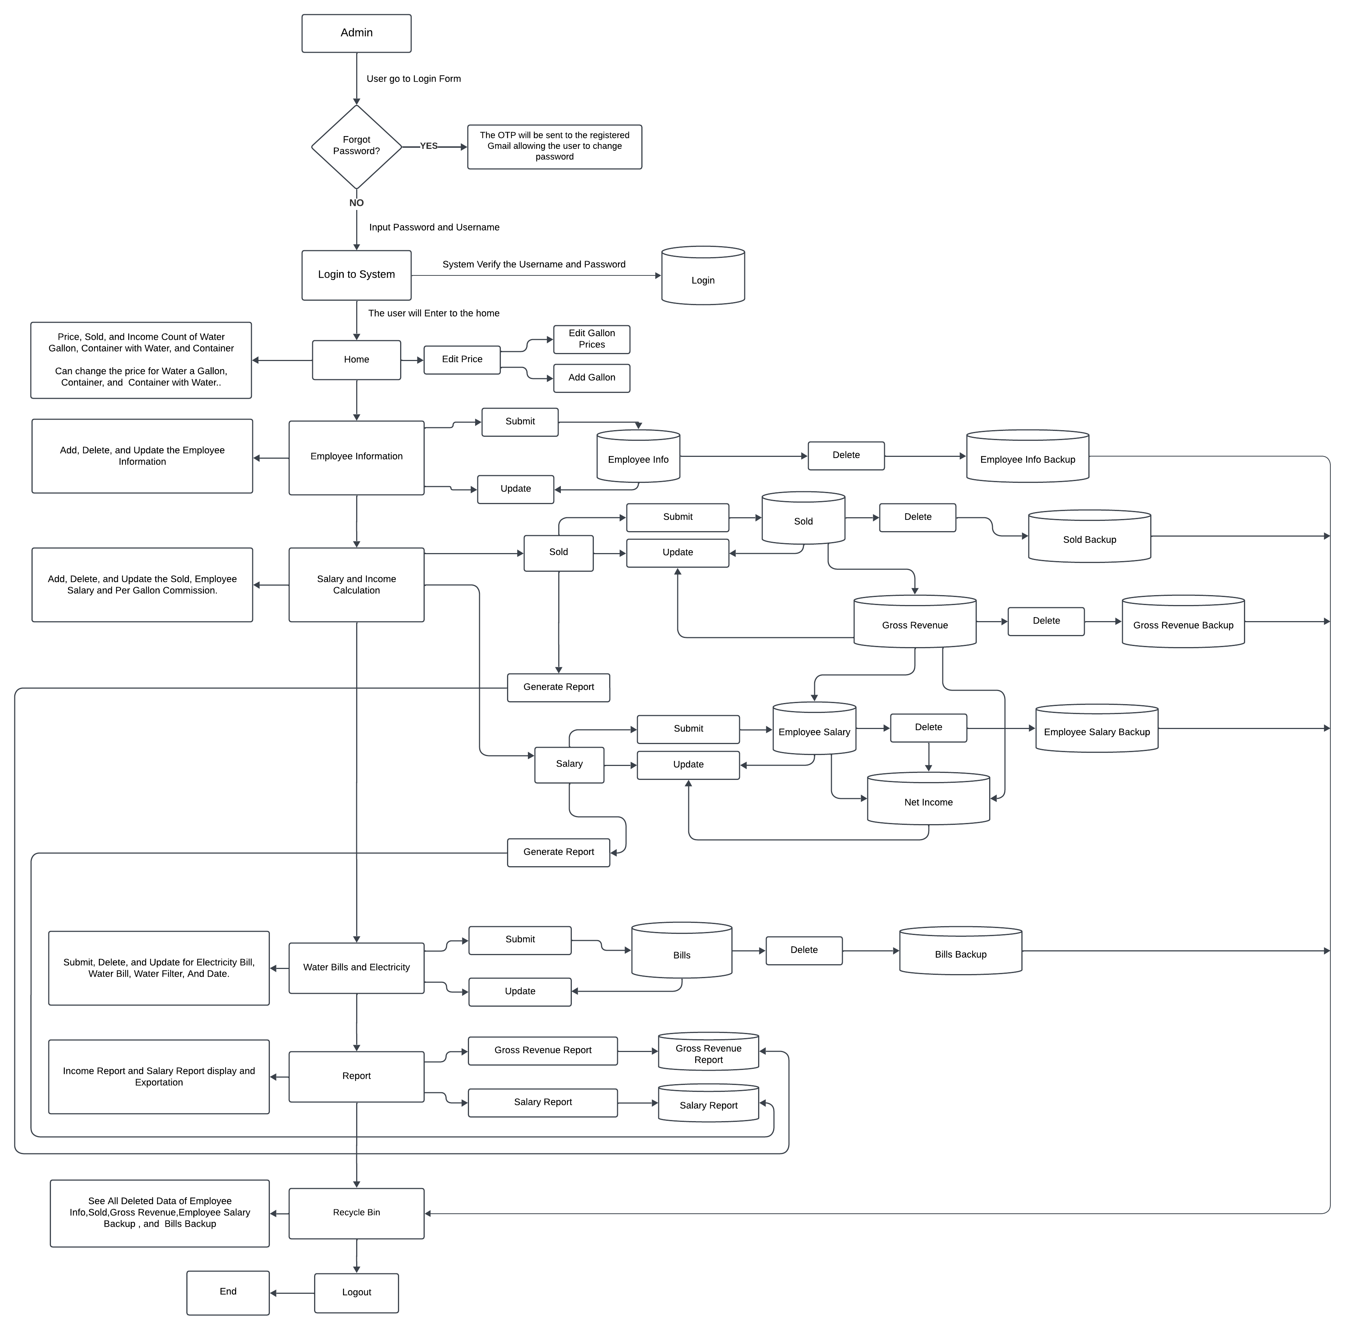

**Figure 1. User Flow of Management System for Au Water Refilling Station**

The user flow diagram provides an overview visualization of how users interact with the Sales and Employee Management System from login to daily operations and report generation.

**System Components**

The Sales and Employee Management System for AU Water Refilling Station is structured into two primary components. The frontend user interface layer and backend application logic layer.

**User Interface Layer (Frontend)**

The Graphical User Interface (GUI) is designed to ensure efficient and user-friendly interaction with the system. The key functionalities include:

1. **User Login & Authentication**. Ensures system security by granting access only to authorized users.
2. **Home Dashboard**. Displays a real-time overview of sales, expenses, and net income, along with the ability to manipulate pricing.
3. **Search Functionality**. Allows users to quickly find records related to employees, sales, and financial transactions.
4. **Sales Management**. Tracks daily transactions, monitors total sales, and ensures accurate revenue recording.
5. **Salary and Income Management**. Computes employee salaries based on commission per gallon delivered and calculates total revenue.
6. **Water Bills and Electricity Tracking**. Records monthly utility expenses for budget planning.
7. **Employee Information Management**. Stores, updates, and manages employee records.
8. **Reports Generation**. Generates comprehensive reports on sales, employee salaries, net income, and expenses for managerial review and decision-making.
9. **Data Backup and Restore**. Ensures data safety by allowing system backups and recovery when needed.
10. **Recycle Bin**. Temporarily stores deleted records, allowing users to restore them when necessary.
11. **Export to Excel**. Provides an option to export financial reports into Excel for further analysis and documentation.

**Application Logic Layer (Backend)**

The backend handles all core processing functions, ensuring system reliability and efficiency through:

1. **User Authentication & Role Management**. Verifies user credentials and restricts access based on predefined roles.
2. **Data Entry & Processing**. Facilitates input of sales data, employee information, and pricing adjustments.
3. **Computerized Computation**. Computerize calculation of employee salaries, revenue, expenses, and net income.
4. **Report Generation & Storage**. Compiles and stores financial data into structured reports for business insights.

**High-Level Component Diagram**

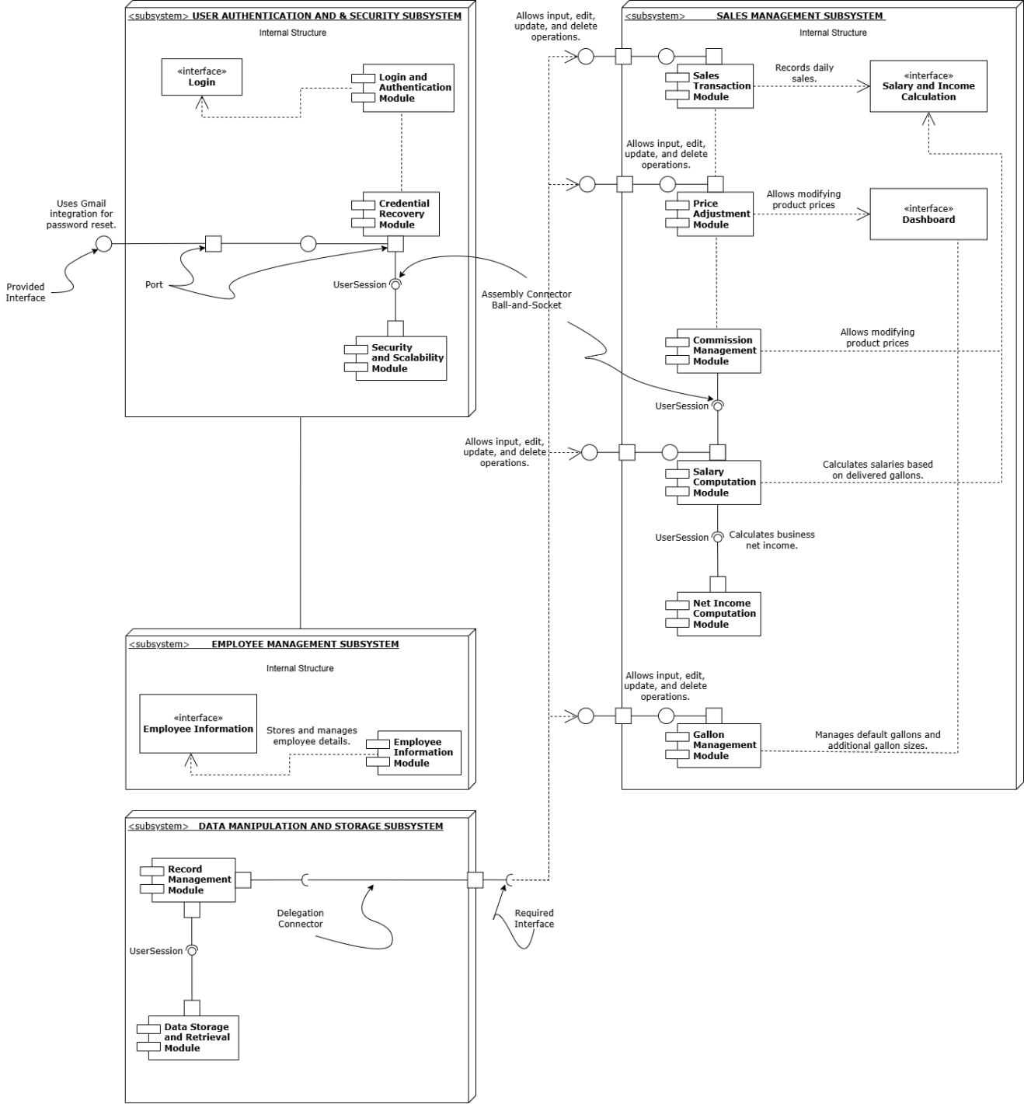

**Figure 2. High-level Component Diagram of AU Water Refilling Station**

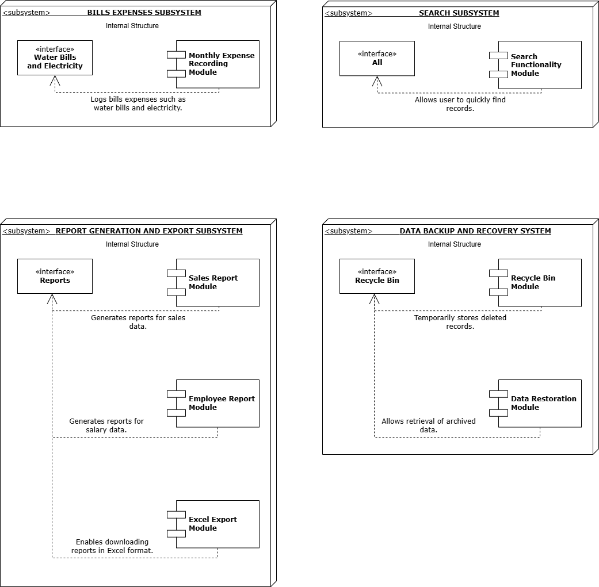

**Figure 3. High-level Component Diagram of AU Water Refilling Station**

This is the high-level component diagram of Sales and Employee Management System for AU Water Refilling Station, it serves as a visual representation for readers such as stakeholders, project team and future readers for their better understanding.

**User Information Management**

This module handles user authentication, ensuring secure access to the system. It includes a login authentication mechanism that verifies user credentials before granting access. Additionally, it integrates Gmail API for credential recovery, allowing users to retrieve forgotten passwords through a secure email verification process. This feature enhances security and ensures a seamless login experience for users.

**Sales Management System**

The Sales Management module is a comprehensive feature designed to manage and monitor daily transactions effectively. It provides the following functionalities:

1. **Price Manipulation.** The system allows authorized users to update and adjust the price of water gallons, ensuring flexibility in pricing based on market conditions.
2. **Gallon Size Management.** This feature enables users to add, modify, or remove different gallon sizes to accommodate varying customer demands.
3. **Daily Net Income Computation.** The system computerized calculates the daily net income based on total sales and deducts operational costs where applicable.
4. **Employee Salary Integration.** This module is interconnected with the Employee Management system, ensuring accurate salary computation based on the number of gallons delivered by each employee.

**Employee Management System**

This module is essential for managing employee information such as manipulation of add, update and delete.

1. **Employee Information.** Users can add, update, and manage employee profiles, including some personal detail.

**Bills Recording System**

The Bills Recording module is designed to track and document all monthly expenses related to the business. It functions as an individual record-keeping feature that provides users with a detailed breakdown of expenses, such as.

1. Utility Bills (Water, Electricity, Internet, etc.)
2. Operational Costs (Maintenance, Supplies, Repairs, etc.)

**Reports Display and Generation**

The Reports Display module allows users to generate comprehensive reports based on data from the Sales Management and Employee Management modules. Reports can be filtered and displayed based on.

1. **Selected Data Rows**. Users can select specific transactions or employee records for reporting.
2. **Monthly Reports**. Generates summaries for a specific month, showing total sales, employee performance, and net income.
3. **Yearly Reports**. Displays annual financial and operational summaries, helping users analyze business growth and trends over time.
4. **Export**. Abled to export the data in own device in case of needing softcopy for business purposes.

**Data Backup and Retrieval System**

This data backup and retrieval feature ensures that deleted information is not permanently lost. It works as a Recycle Bin or Archive System, where deleted sales and employee data are temporarily stored. The key functions include:

1. **Data Restoration**. If needed, users can retrieve and restore deleted records from the archive, ensuring data integrity and preventing accidental loss.
2. **Secure Data Management**. The archived data remains protected and accessible only to authorized users.

**INSTALLATION GUIDE**

An installation guide is a list of step-by-step instructions regarding the setup of software, hardware, or systems to ensure proper working. It involves the tools needed, configurations, and procedures a user must undergo during the installation.

**Hardware Requirements**

The hardware requirements ensure the capability of the system to run properly and smoothly in the desktop device with least encountered problems occur.

* **Processor.** Intel Core i3 or higher
* **RAM.** Minimum 8GB
* **Hard Drive.** 256GB SSD or higher
* **Display.** Minimum resolution ng 1024 x 768 pixels

**Software Requirements**

The software requirements ensure the compatibility of the system to run and operates accordingly.

* **Operating System.** Windows 10/11 (64-bit)
* **Development Platform.** Visual Studio 2010 Ultimate / Professional
* **Database Management System.** SQL Server Management Studio Management Studio 19
* **Framework.** .NET Framework 4.0

**Step-by-Step Instructions for Installing the Software**

Step-by-step instruction helps the developer team and stakeholder to align the goal and meet the criteria in proper installation. It gives them a precise procedure to make the installation works smoothly.

**Step 1. Install SQL Server Management Studio (SSMS)**We will download the SQL Server Management Studio (SSMS) installer onto the user's server. After the SSMS is downloaded, we will proceed with the installation setup on the user's server or unit.

**Step 2. Transfer the System Installer**

After installing SSMS on the user's server or device, the next step is to transfer all the system files we created, including the .exe file. We will thoroughly verify that all the files are intact to prevent any problems when using the system.

**Step 3. Import the Database to SSMS**

After transferring the system files and the .exe file, and downloading SSMS, the next step is to import the required database for the system. Here’s how to do it:

1. Open SQL Server Management Studio (SSMS).
2. Go to the Databases folder.
3. Right-click on Databases and choose Import Data-tier Application.
4. Follow the prompts to complete the database import into the system.

**Step 4. Run the System**

Once we finish all the necessary steps for the system installation, we will proceed to test it to confirm everything is functioning as expected. This involves checking that the installation was completed correctly, ensuring all features are operational, and verifying that the database is running smoothly.

**CONFIGURATION GUIDE**

This is a simple step-by-step instruction manual that helps users make changes or updates in a system. This guide specifically explains how to update your account password, including logging in, navigating to the settings, entering your current and new passwords, saving the changes, and confirming the update. It also provides tips for troubleshooting errors and using the "Forgot Password" option if needed.

**System User Guide: Changing Password**

This guide will help the user change the account password in the system. Follow these steps carefully.

**Access the System**

1. Open the application on your device.
2. Log in with the user’s existing username and password.

**Navigate to the Password Update Section**

1. After logging in, go to the setting.
2. Update form.
3. Select the current data row.
4. Enter the current password.
5. In the current password make sure to input the existing password.

**Enter New Password**

1. In the new password field, type the new password to use.
2. Make sure the new password that entered must not match the current password.

**Confirm Your New Password**

1. In the confirm password field, re-enter the new password exactly as being typed above.
2. Ensure there are no typos.

**Save Changes**

1. Click the update button.
2. Wait for the system to process the changes.

**Confirmation**

1. If update is successful, users will see a confirmation message like.

*“User Profile Update Successfully.”*

1. If there are errors, follow the instruction provided by system (e.g. *“Current password is incorrect”* or *“The New Password and Confirmation Password do not match.”*

**Log in with Your New Password**

1. Log out the System.
2. Use the new password to log back in and confirm it works.

**Note:** If you forget your current password, use the forgot password option the password will send to your registered email account.

**API DOCUMENTATION**

The log-in form is an authentication method that confirms that the user is valid in using the system. To ensure the safety of the user once he forgets his email or password, the user has the option to retrieve the account with the help of the forgotten password indicated in the login form itself for the account retrieval option. When pressing the forgotten password, it appears to ask for the user's Gmail account to verify the user. This third party and database are connected. The third party interacts with the system's database to access the user record data.

The database is required to communicate with the third party to acquire the third party's need to obtain the content of the user's data record and convert it into a message to send a message indicating the email and password for the user and send it to the Gmail account of the user in such a way that the user can see the message sent by the third party indicated the user's email and password to allow such account to be opened for the system.

**API Overview**

This API provides authentication functionality, allowing users to log in securely and recover their accounts if they forget their password.

**API Endpoints**

|  |  |  |
| --- | --- | --- |
| Method | Endpoint | Description |
| POST | /api/auth/login | Authenticates a user using email & password |
| POST | /api/auth/forgot-password | Requests password reset, sends OTP to registered Gmail. |
| POST | /api/auth/verify-otp | Verifies the OTP entered by the user. |
| POST | /api/auth/reset-password | Allows users to set a new password after OTP verification. |

**API Details**

**Login API**

1. Endpoint. POST /api/auth/login
2. Request Body. {“username": "*registered username*", "password": "*registered password*”}
3. Response (Success – 200 OK). {“message": "Login successful", "token": "*the token...*”}
4. Response (Error – 401 Unauthorized). {“error": "Invalid username or password", "Login Failed”}

**Forgot Password API**

1. Endpoint. POST /api/auth/forgot-password
2. Request Body. {“email": "*the registered Gmail account*”}
3. Response (Success - 200 OK). {“message": "An OTP has been sent to your email. Please check your inbox.", "Success”}
4. Response (Error - 404 Not Found). {“error": "The email address you entered is not registered in the user profile.", "Error"}

**OTP Verification API**

1. Endpoint. POST /api/auth/verify-otp
2. Request Body. {“email": "*the registered Gmail account*”, “otp”, “*generated otp”*}
3. Response (Success - 200 OK). (No message, proceed to change password)
4. Response (Error - 404 Not Found). {“error": "The email address you entered is not registered in the user profile.", "Error"}

**Recovery Flow**

* + - 1. The user enters their username and password in the login form.
      2. If the user forgets their password, they can select the Forgot Password option.
      3. The system prompts the user to enter their registered Gmail account.
      4. Once submitted, the system verifies if the email exists in the database.
      5. If the email is valid, the system generates a One-Time Password (OTP) and sends it to the user via Gmail.
      6. The user checks their Gmail inbox for the OTP and enters it into the application.
      7. The system validates the OTP.
* If the OTP is correct, the user proceeds to the Change Password screen.
* If the OTP is incorrect or expired, the system prompts the user to request a new OTP.
  + - 1. The user enters and confirms a new password in the Change Password form.
      2. The user enters and confirms a new password in the Change Password form.
      3. The system updates the user's password in the database.
      4. The user is redirected to the login screen, where they can now access the system using the new password.

**DATABASE DOCUMENTATION**

This is the graphic representation that depicts relationships, objects, place, or concepts in information technology. It helps by providing a clear and structured visualization of data and relationships within the Sales and Management System.

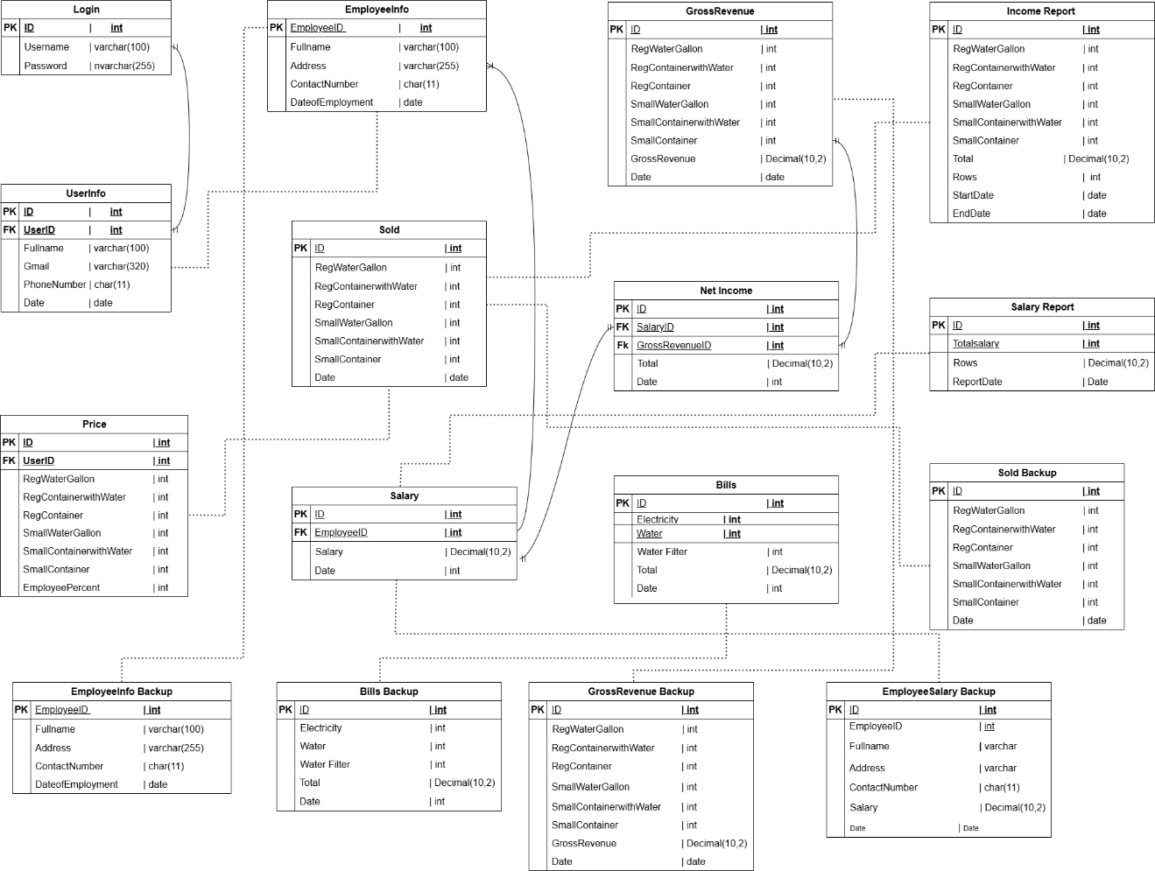

**Figure 3. Database Schema Diagram for Au Water Refilling Station**

This figure shows the relationship of some tables in order to achieve the efficient work flow of processes in the system.

**Tables Information**

These are the descriptions of database tables, fields, and relationships.

**Login**

Login table is a storage for the credentials that will be used of the user to log in into the system. It holds fields such as username and password that is used for validation if the account exists whenever a login attempt occurs.

**UserInfo**

UserInfo table is a storage for the user information, it holds the basic information of the user and displayed in the setting form it includes the username of the user; therefore, it has relationship with the Login to be able to get the username and display as well with the rest of information of the user.

**Price**

Price table holds the prices that has been set by the user for their gallon pricing, the value that set by the user is used in computerized computation for the sold or sales management.

**EmployeeInfo**

EmployeeInfo table is a container of basic information regarding the employees, such as delivery boys. It is used to holds their basic information and a base for getting an amount of the salary of the employee per day depends on their gallon delivery.

**Sold**

Sold table contains the total revenue for every gallon size, gallon with water, and just a container that has been sold for daily record.

**Salary**

Salary table holds the salary amount of the employee in their daily. It is connected to the EmployeeInfo table to get the EmployeeID to store the correct amount of salary of the specific employee. It ensures the precisely salary management recording.

**GrossRevenue**

GrossRevenue table holds the converted value of total sales of the day inputted by the user. It holds the total amount of each type of product in the business.

**NetIncome**

NetIncome holds the total income of the day, the value is from the Salary and GrossRevenue. This table has a relationship to the both of the tables to get the total salary net income for the day.

**Bills**

Bills table holds the amount of expenses by the user, it is a storage of record of expenses in their business.

**IncomeReport**

This IncomeReport table holds the generated income of the selected dates from the sold page.

**SalaryReport**

SalaryReport table holds the generated salary of the selected dates from the salary page.

**Every Backup Tables**

All of the backup table is a container that holds the deleted data from the specified functions, it acts like an archive storage that stores data and still available for retrieval once needed.

**USER MANUAL**

Provides a step-by-step guide on how to use the sales and employee management system properly avoiding malfunctions and application error.

**Step-by-step guide in using AU Sales and Employee Salary System**

The use of guide in using a new develop application is crucial because it acts as a comprehensive guide for users to understand the application's features, functions, and how to navigate the interface, enabling them to quickly learn and utilize the app effectively, minimizing the learning curve and improving user adoption while reducing the need for extensive training or support calls. For AU sales and employee management system here is the step-by-step guide in using it.

1. **Logging into the System**

1. Open the AU Sales and Employee Salary System on your computer.

2. Enter your **username** and **password**.  
3. Click **Login** to access the system.

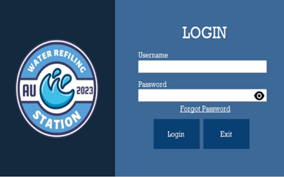

* 1. **Additional Functions on Logging into the System**

1. Click the **eye icon** to show password.  
2. Click **forgot password** to recover the account.  
3. Click **Exit** if you want to close the system.

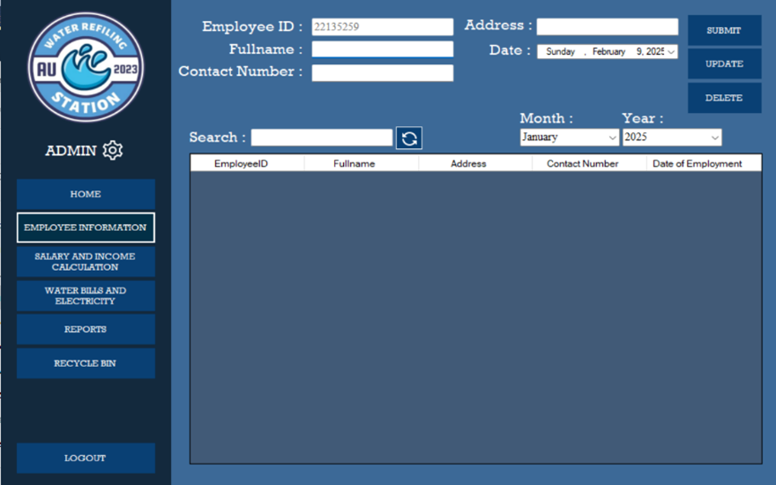

1. **Input Employee Information**1. Navigate to the **Employee Information** section.  
   2. To **Add New Employee**. Fill in the required fields.  
    • Full Name

• Contact Number

• Address

• Date (for the date of employment)

3. Click **Submit** to save the employee information.

* 1. **Updating Employee Information**1. Go to the **Employee Information.**  
     2. Below is the table where you can see the list of employees. Click the row of employee whose details need updating.

3. The employee details will show on the text fields. Make the necessary changes, and then click **Update**.  
4. The updated details of the employee will show on the table list.

* 1. **Deleting Employee Information**1. Go to the **Employee Information**.  
     2. Below is the table where you can see the list of employees. Click the row of employee whose details need to delete.

1. Click **Delete**, a **confirmation message** will show. Choose **Yes** to continue deleting the employee details and **No** if not.
   1. **Searching Employee Information**  
      1. Go to the **Employee Information.**2. Look for the label **Search**. Beside is a text field where you can input the name of the employee.  
      3. After entering the **employee’s name**, the table below will show the information of the employee.
   2. **Sorting employee information**1. Go to the **Employee Information.**2. Look for the label **Month** and **Year.** Below of these are dropdown list where you can choose from.  
      3. Select the **Month** or **Year** you want.  
      4. After selecting, the table below will show the information on employee base on selected month and year of their employment.

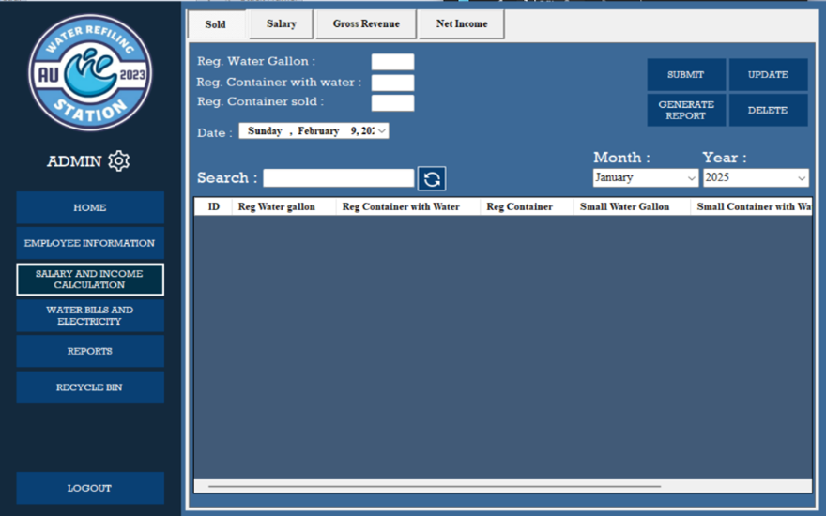

1. **Recording Sales**1. Go to **Salary and Income Computation.**  
   2. Navigate to the **Sold** section.  
   3. To **add the sales** for a day you need to fill in required fields such as.  
    - Reg. Water Gallon  
    - Reg. Container with water  
    - Reg. Container sold  
    - Date  
   4. After filling out the necessary fields. Click **Submit** to save the sales.  
   1. **Updating Sales**1. To update the Sales, Click the **row** you want to update.  
      2. Modify on what sales by choosing what you want to update and change the quantity. Choose from:  
       - Reg. Water Gallon  
       - Reg. Container with Water  
       - Reg. Container Sold
2. Click **Update** and the updated quantity of sales will computerize update and save.
   1. **Deleting Sales**1. To Delete the Sales, Click the **row** you want to delete.  
      2. Click **Delete** and a message will show asking if you really want to delete the information. Choose **Yes** if you wish to proceed and **No** if not.
   2. **Searching and sorting sales**1. Go to Salary and Income Computation  
      2. Navigate to the Sold section.  
      3. From there, you will see a Search label with a search bar.  
      4. In the search bar, you can type the quantity of sold items to search a specific detail you are looking for.  
      5. For sorting the details you need, below is the month and year. You can choose a specific month or year to sort the record of sold below.  
      6. After choosing the month or year or month and year, the record will show the record the chosen way of sorting.

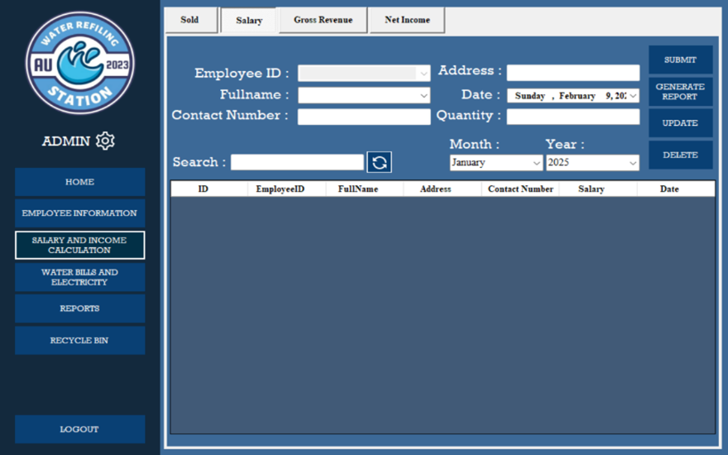

**Processing Employee Salary**

1. Go to **Salary and Income Computation**.
2. Navigate to the Salary section.
3. To compute the salary of an employee, you need to choose the employee’s name beside the label **full name**. It’s a drop-down list where you need to choose the name of the employee and it shows their details such as Employee ID, Contact Number, and Address.
4. To compute his/her salary, you need to input the **quantity of gallon** sold that day on the Quantity text field.
5. After inputting the quantity that employee sold that day. Click the **Submit** and it shows the **calculated salary** of the employee on the table below.
6. **Updating Employee Salary**1. To **update** employee salary record, click the row you want to update.  
   2. After clicking the row, you can only update the **date** and the **quantity** that the employee sold.   
   3. After editing the quantity or the date. Click **Update** and the updated information will be saved.
7. **Deleting Employee Salary**
8. To delete the employee salary record, click the row you want to delete.
9. After clicking the row, click **Delete** a message will show asking if you really want to delete the information. Choose **Yes** if you wish to proceed and **No** if not.

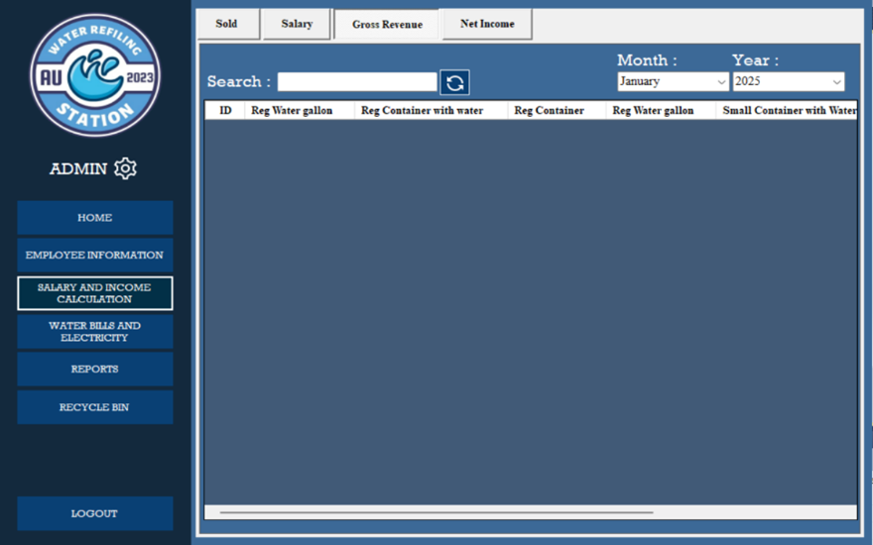

1. **Gross Revenue** Record  
   1. Go to **Salary and Income Computation.**  
   2. Navigate to the Gross **Revenue** section.  
   3. In the **Gross Revenue** section, you will see the list of the sales of the shop.   
   4. Below the table, you will see a scroll bar. All the records of sales will show and at the end of row, you will see the Gross Revenue for that day.
   1. **Gross Revenue** Record Searching and Sorting  
      1. Go to **Salary and Income Computation**  
      2. Navigate to **Gross Revenue** section  
      3. In the **Gross Revenue** section, you will see Search, Month, and Year labels.  
      4. To **Search**, just input an amount to show the row with the amount you are looking for.  
      5. To **Sort** the record, there is a drop-down list for **Month** and **Year**. Choose a year or month or month and year and it will computerized show all the details from your chosen Month or year or Month and Year.

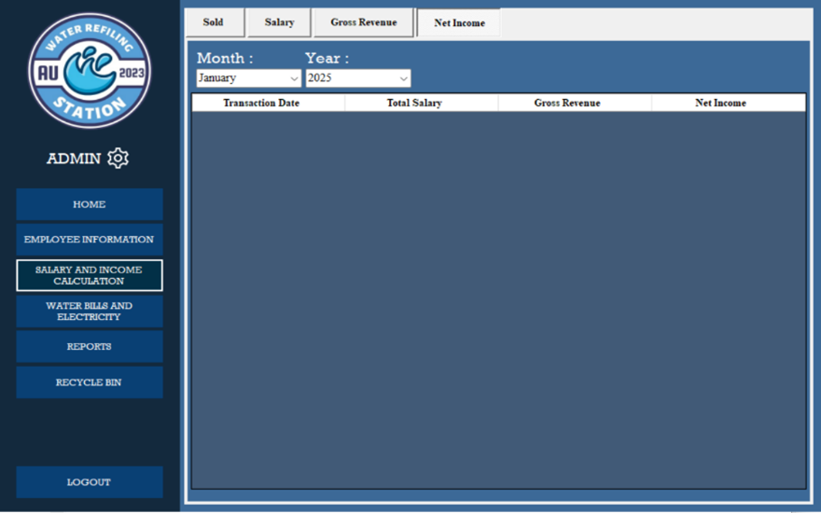

1. **Net Income Record**1.To access the **Net Income Record,** Go to **Salary and Income Calculation.**2. Navigate to the Net **Income** section.  
   3. On the net income section, you will see the record of the income generated.
   1. **Sorting Net Income Record**1. To access the **Net Income Record,** Go to **Salary and Income Calculation.**2. Navigate to the Net **Income** section.  
      3. You can sort the record of net income by choosing a month or a year or month and year in a drop-down list.  
      4. After selecting on what way do you want to sort the record, it will computerized sort and show the record with the chosen format.

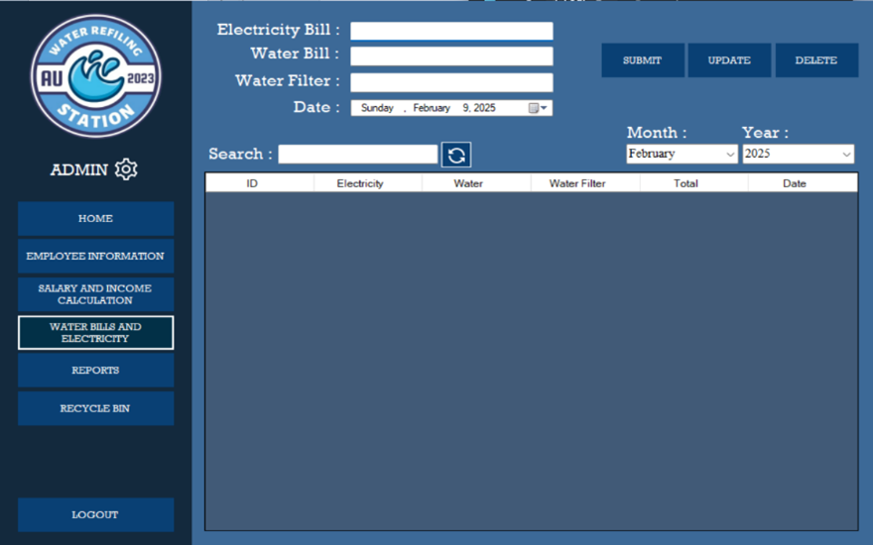

1. **Recording Utility Bills**1. Go to **Water and Electricity**.  
   2. To record a bill. Fill in the required fields.  
    - Electricity Bill  
    - Water Bill  
    - Water Filter  
    - Date  
   3. Click **Submit** to save the expenses for utility bills.
   1. **Updating records of Utility Bills**1. Go to **Water and Electricity**.2. To update utility bills, click the **row of data.**  
      3. Modify the changes you want to update.  
      4. After modifying, click **Update** and the modified changes will be saved and update
   2. **Deleting records of Utility Bills**1. Go to **Water and Electricity**.2. To update utility bills, click the **row of data.**
2. Modify the changes you want to update.
3. After modifying, click **Update** and the modified changes will be saved and update.
   1. **Searching and Sorting Utility Bills record**1. Go to **Water and Electricity**.2. To **search** a specific utility bill, there is a label Search and beside it is a Search text field where you can type in a specified amount you are looking for**.**  
      3. After typing the specified amount you are looking for, the list below will show all the records that are the same as what you are searching for.  
      5. To **Sort** the bills record, you can choose from a drop-down list under the Month and Year. You can sort by month, year, or by month and year.  
      6. After choosing a way to sort the records, it will computerized show the records.

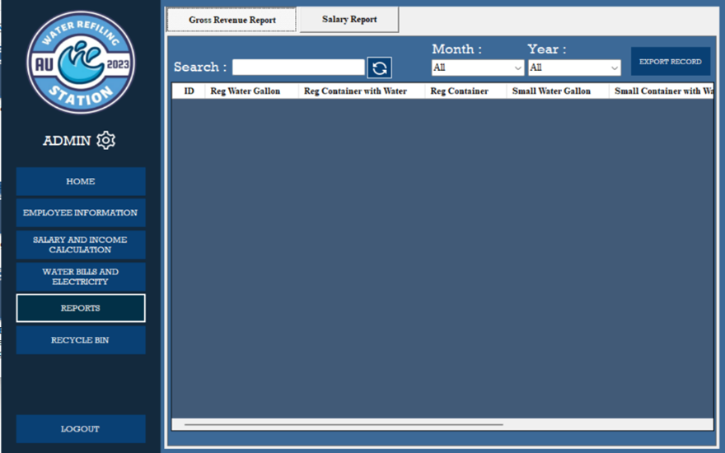

1. **Generating Gross Revenue Reports**
2. Go to **Salary and Income Calculations**
3. Navigate to **Sold** section.
4. Go to records below the search label.
5. Select **at least two or more rows** using the Shift key or Ctrl key.
6. After selecting the rows, Click **Generate Report**.
7. A message will show asking if you want to generate a report. Click **Yes** to proceed with creating the report and **No** if not.
8. After clicking yes, Go to **Reports.**
9. Navigate to **Gross Revenue Report.**
10. You can now see the records of the Gross Revenue Report. Use the scroll bar below to see all the content of the records.
    1. **Searching and Sorting Gross Revenue Reports**1. Go to **Reports**  
       2. Navigate to the Gross **Revenue Reports** section.3. Beside **Search** label is a text field where you can enter what data you are looking for.  
       4. After entering the data you are looking for, the records below will show the data that match from the data you enter on the search text field.  
       5. To sort records, you can use the drop-down list under the **Month** and **Year** label. Form the drop-down list, you can choose a month and a year or both to sort the records.  
       6. After choosing on how you want to sort the records, it will computerized show the sorted that match to the month, year, or both you selected.
    2. **Downloading soft copy of Gross Revenue Reports**1. Go to **Reports.**  
       2. Navigate to the Gross **Revenue Reports** section.

3. On the records table, **select rows** you want to generate a soft copy report.  
4. After selecting, click the **Export Record**.  
5**. Choose a folder** on your file manager you want to save the report.  
6. Click **Save** and an excel file of the reports is save on your **computer’s file manager.**

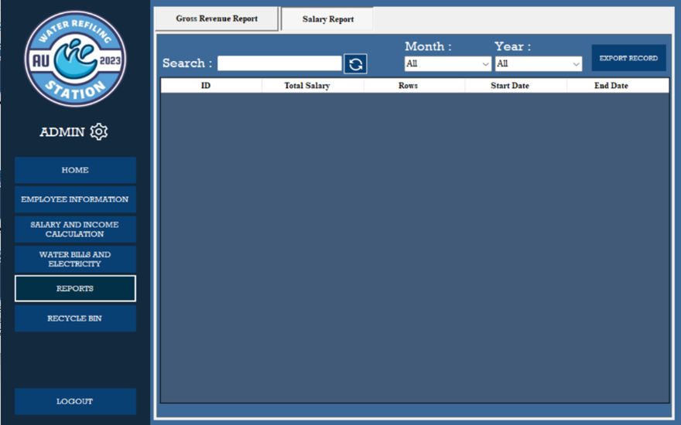

1. **Generating Salary Reports**1. Go to **Salary and Income Calculations.**2. Navigate to **Salary** section.  
   3. Go to records below the search label.  
   4. Select **at least two or more rows** using the Shift key or Ctrl key.  
   5. After selecting the rows, Click **Generate Report**.  
   6. A message will show asking if you want to generate a report. Click **Yes** to proceed with creating the report and **No** if not.7. After clicking yes, Go to **Reports.**  
   8. Navigate to **Salary Report.**  
   9. You can now see the records of salary Report.
   1. **Searching and Sorting Salary Reports**1. Go to **Reports.**  
      2. Navigate to **Salary Reports** section**.**3. Beside **Search** label is a text field where you can enter what data you are looking.  
      4. After entering the data you are looking for, the records below will show the data that match from the data you enter on the search text field.
2. To sort records, you can use the drop-down list under the **Month** and **Year** label. Form the drop-down list, you can choose a month and a year or both to sort the records.
3. After choosing on how you want to sort the records, it will computerized show the sorted that match to the month, year, or both you selected.
   1. **Downloading Soft Copy of Salary Reports**1. Go to **Reports.**  
      2. Navigate to the Salary **Reports** section.

3. On the records table, **select rows** you want to generate a soft copy report.  
4. After selecting, click the **Export Record**.  
5**. Choose a folder** on your file manager you want to save the report.  
6. Click **Save** and an excel file of the reports is save on your **computer’s file manager.**

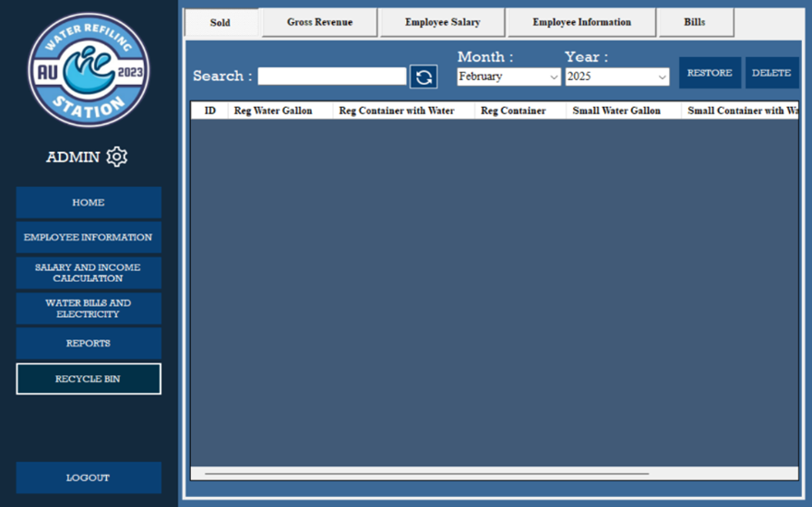

1. **Recovering a Deleted Information**1. Go to the Recycle **Bin.**  
   2. Navigate to the section **where you want to restore deleted information**.

3. On the records table, **select rows** you want to recover.  
4. After selecting, click the **Restore**.

1. A message will show saying that the selected row successfully recovers.
2. Go to the section where you recovered the information and it will show the recovered data. For example, you restore data from the sold section in the recycle bin. The restored data will show at the sold section under the salary and income computation.

10.1 **Permanently Deleting an information**

1. Go to the Recycle **Bin.**
2. Navigate to the section **where you want to permanently delete the information**.
3. On the records table, **select rows** you want to permanently delete.
4. After selecting, click the **Delete**.
5. A warning message will show saying that you are sure you want to delete the data. Click **Yes** if you want to proceed and **No** if not.

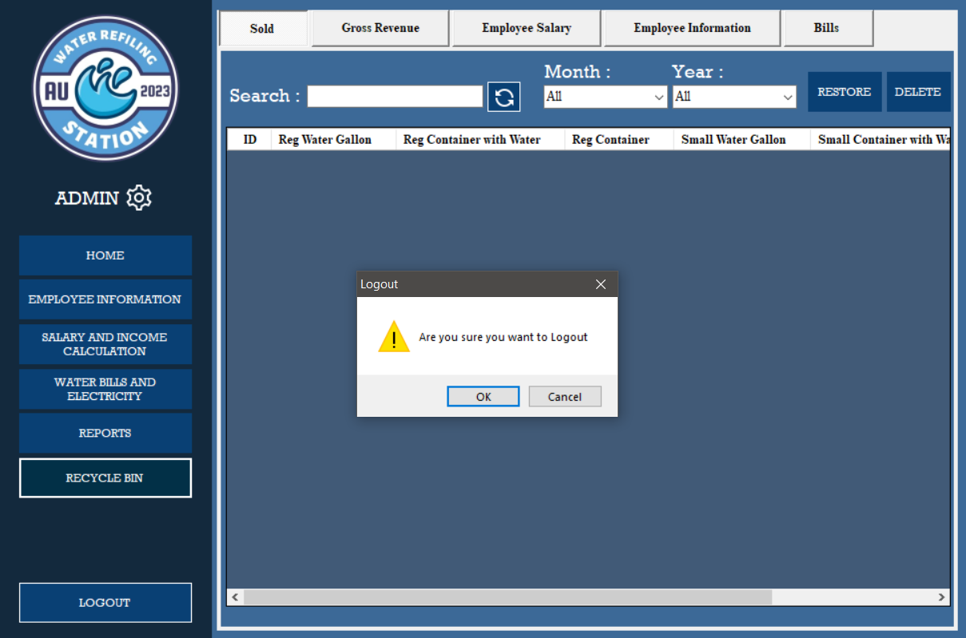

1. **Logging out from the System**  
   1. On the option bar, click **Log Out**.  
   2. A message will show asking if you are sure to log out.  
   3. Click **Yes** to log out and **No** if not.
2. **Closing the application**1. After logging out, the log in form will show.  
   2. Click **Exit**, a message will pop up. Click **OK** if you want to proceed to exit the application and **cancel** if not.

**TROUBLESHOOTING GUIDE**

This is a troubleshooting guide; it is intended to help the user or our stakeholder to identify and resolve possibly common issues encountered while using the Sales and Employee Management System for Au Water Refilling Station.

Therefore, we listed common issues and answer for the user to follow. The steps are outlined below to quickly address the mentioned challenges.

**General Troubleshooting Steps**

Before diving into the specific issues, kindly try these general steps.

1. Restart the software application by clicking the close or exit.
2. If there has problem in closing the application and trying to navigate the Task Manager, you can open the Task Manager by pressing the ALT + CTRL + Del shortcut keys in your keyboard and click the “Task Manager”. When the Task Manager appears, find the running software application in processes and background processes. Select the running application, press right click of your mouse then click “End Task”.
3. If the same problem occurs, let’s deep dive in common issues and solutions.

**Common Issues and Solution**

**Au Water Software Application fails to Load**

If the system doesn’t open when tried opening it there are possible causes.

1. It was already open or running.
2. The computer system requires it to run as an administrator.
3. Incompatible software version.

**Solution**

1. Check the icon in the taskbar if the system is already running.
2. Click right click on the application and select run as an administrator to open.
3. If the issue is incompatible with the software version, contact technical support.

**Unable to Login**

User cannot log in after trying multiple times using her credential.

1. Incorrect username or password.
2. Forgot Password using Gmail is not working.

**Solution**

1. Obtaining the credential using a forgotten password.
2. Double check the email, must be the saved email on the database of an application.

**Problem on Data Input**

User encounter problem when inputting data.

1. The field requirement doesn’t meet.
2. All necessary fields must not leave on blank.

**Solution**

1. Check the error messages to see what kind of error has occur.
2. Make sure to fill all the fields needed and not leave blank, user must put “0” if the data in sales should be none.

**Contact Support**

If the problem persists or is not listed in this guide, please contact our support team for further assistance. Provide the following information when reaching out.

**Support Email:** mail.org.noreply@gmail.com

**Note:** When sending us a concern kindly include your contact information as well so, we the development team can contact you directly as soon as we read your email to our support services mail.

**CODE DOCUMENTATION**

This code documentation explains how the piece of code works, it helps developers understand, use, and maintain the code efficiently. It also can be a guide for future researchers to understand the structure and flow of the development and the important components that has been used by the software engineer in developing the system.

**Connection Class**

The connection class is responsible for establishing a secure connection between the application and the SQL Server database. This class ensures efficient data retrieval, insertion, updating, and deletion operations while handling potential database connection issues. In the connection class, the declaration was done each form because of the software engineer limitation of not using the module by the reason of not being much familiarized of its functionality.

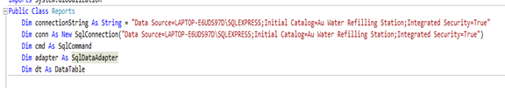

**Image 1. One of the Connection Class: Reports**

**Explanation of Functionality**

1. **Define Connection String**. Stores database connection details, including server name, database, and authentication mode.
2. **Initialize Connection.** Creates a SqlConnection object using the connection string to establish a connection to the database.
3. **Prepare SQL Command.** Declares a SqlCommand object for executing SQL queries (SELECT, INSERT, UPDATE, DELETE).
4. **Initialize Data Adapter.** Declares a SqlDataAdapter to fetch data from the database and fill a DataTable.
5. **Define Data Table**. Declares a DataTable to store retrieved data for display or processing.

**Login Form**

The login form serves as the authentication mechanism for the system. It ensures that only valid user can access the system by verifying the input credentials against the database.

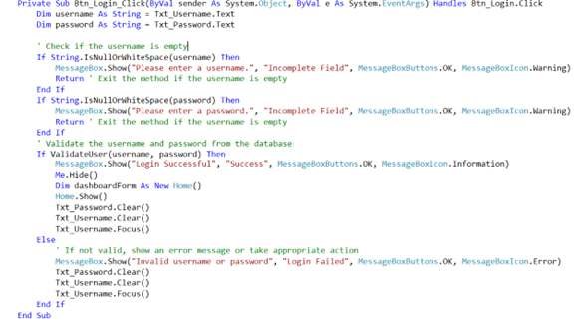

**Image 2. Login Validation**

**Explanation of Functionality**

1. **Retrieve Input.** Captures the username and password from Txt_Username and Txt_Password.
2. **Validate Input.** Checks if the username or password fields are empty and prompts the user if necessary.
3. **Authenticate User.** Calls ValidateUser(username, password) to verify credentials against the database.
4. **Successful Login.** Shows a success message, hides the login form, opens the home form, and clears input fields.
5. **Failed Login.** Shows an error message, clears input fields, and refocuses on Txt_Username.

**Forgot Password**

The Forgot Password functionality allows users to recover their account in case they forget their login credentials. It ensures account security by verifying the user’s registered email and providing a secure way to reset the password. The process involves user verification, generating a reset token, sending a reset link via email, and updating the password in the database. This feature integrates with a third-party email service Gmail to send password recovery instructions to the user’s registered email address.

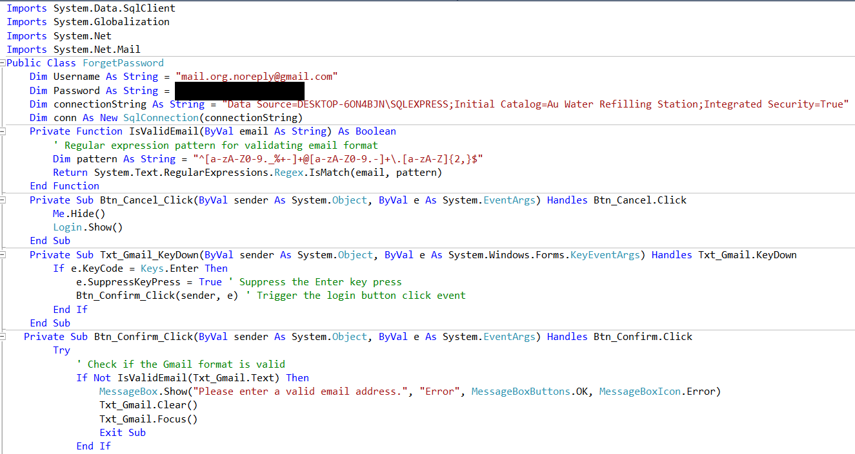

**Image 3. Forgot Password and API**

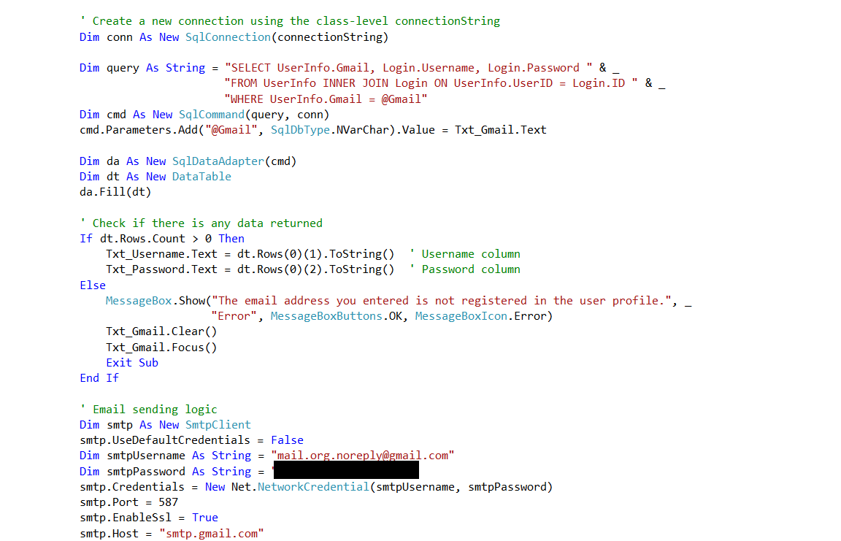

**Image 4. Forgot Password and API**

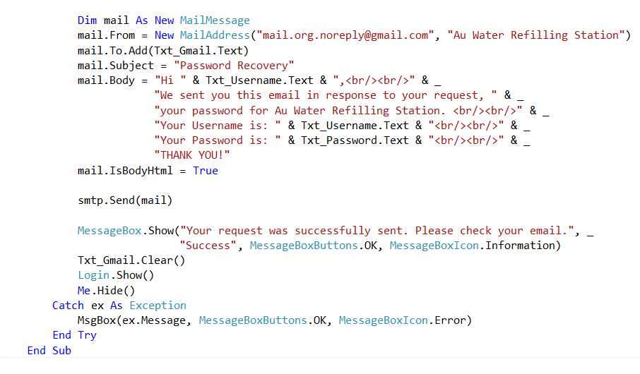

**Image 5. Forgot Password and API**

**Explanation of Functionality**

1. **Validate Email Input**. The system checks if the entered email in Txt_Gmail is valid using the IsValidEmail() function.
2. **Handle Invalid Email**. If the email is invalid, an error message is displayed, and the email textbox is cleared.
3. **Connect to Database.** Uses SqlConnection to establish a connection with the database.
4. **Execute SQL Query.** Searches for the username and password in the Login table where the email matches the entered one.
5. **Check Query Result**. If a record is found, the username and password are displayed in the textboxes. If no record is found, an error message is shown, and the email field is reset.
6. **Send Recovery Email**. Uses SMTP Client to send an email containing login details to the user's Gmail account.
7. **Ensure Email Delivery**. The system requires correct email credentials and SMTP server settings to send the email successfully.

**Sold**

The sold functionality allows user to record the daily sales of the business. Every amount that has been input to the fields has multiplier base on the prices of the gallon. This ensures to adapt the functionality of recording of user from manual to computerized way.

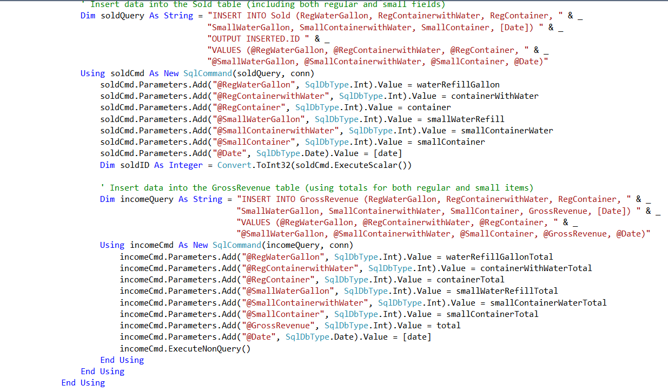

**Image 6. Sold Query**

**Explanation and Functionality**

1. **Input Sales Amount.** The user enters the total sales amount for the specific day.
2. **Retrieve Price per Gallon.** The system fetches the user-defined price per gallon from the database or settings.
3. **Calculate Gross Revenue.** Multiplies the entered sales amount by the price per gallon to determine total revenue.
4. **Store Sales Record.** Saves the sales amount, price per gallon, gross revenue, and date in the database.
5. **Display Results.** Shows the total revenue and stored sales information to the user.
6. **Confirm Submission.** Notifies the user that the sales record has been successfully saved.

**Salary**

The salary functionality records employee salaries based on the number of gallons delivered by a delivery employee. The user selects a specific employee, inputs the number of gallons delivered, and submits the data. The system then calculates the salary based on the set commission per gallon and stores the salary record.

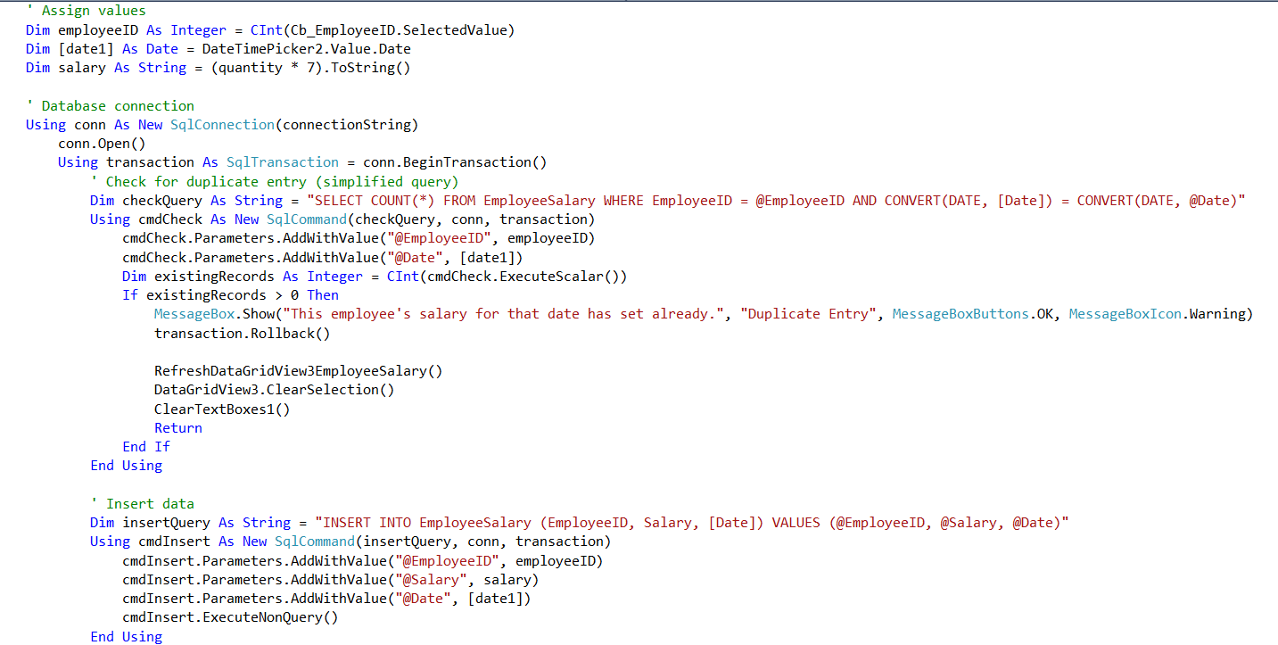

**Image 6. Salary Query**

**Explanation and Functionality**

1. **Select Employee.** The user selects the delivery employee from a list.
2. **Input Delivered Quantity.** The user enters the number of gallons delivered by the employee.
3. **Retrieve Commission Rate.** The system fetches the predefined commission per gallon from the database.
4. **Calculate Salary.** Multiplies the delivered quantity by the commission rate per gallon.
5. **Store Salary Record.** Saves the employee’s name, delivered quantity, commission rate, total salary, and date in the database.
6. **Display Salary Details.** Shows the computed salary and stored record for confirmation.

**Searches**

The SearchByMonthYear function retrieves and displays data from the database based on the selected month and year. It filters entries from the table by checking the StartDate column, ensuring that only records matching the specified month and year are shown.

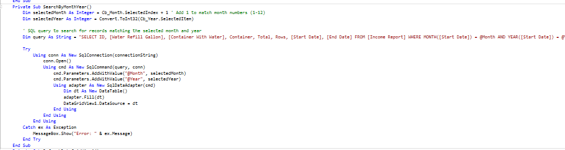

**Image 6. Search Functionality**

**Explanation and Functionality**

1. **Input Month & Year.** The user selects or enters a specific month and year.
2. **Query the Database**. The system executes an SQL query to filter records based on the month and year of the Start Date column.
3. **Retrieve Data**. The matching records are fetched from the database.
4. **Display Results**. The filtered data is shown in the table or UI component.
5. **Handle No Results**. If no records match the criteria, a message is displayed indicating no data found.

**Generate Reports**

The Generate Reports function allows users to select multiple rows from the table, fetch the corresponding data, and determine a date range based on the selected entries. This enables users to generate and view a sales report covering the selected days.

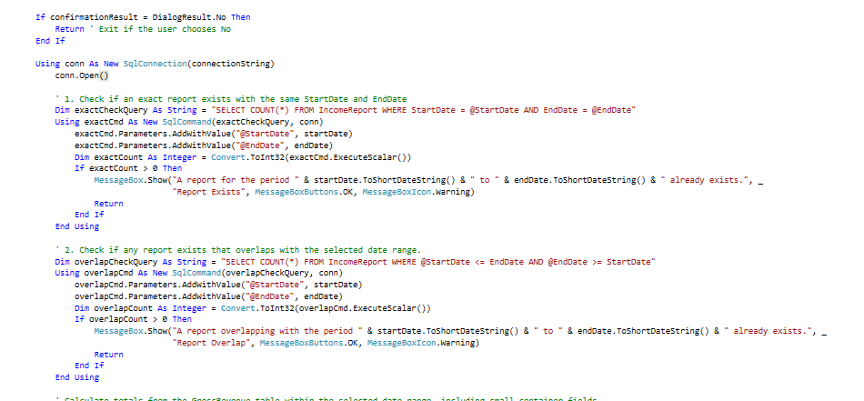

**Image 7. One of the Generate Report: Income Report**

**Explanation and Functionality**

1. **Select Multiple Rows.** The user selects multiple rows from the sales table.
2. **Fetch Selected Data.** The system retrieves the data for the selected rows from the database.
3. **Determine Date Range.** The system reads the Start Date values of the selected entries and determines the range.
4. **Generate Report.** The system compiles the data into a structured report format.
5. **Display Report.** The generated report is displayed to the user, showing sales data for the selected days.

**Export Reports**

The Export Reports function allows users to select one or multiple rows from the table and export the data to a file format of their choice. Once the Export button is clicked, the system prompts the user to choose a location on their device to save the file.

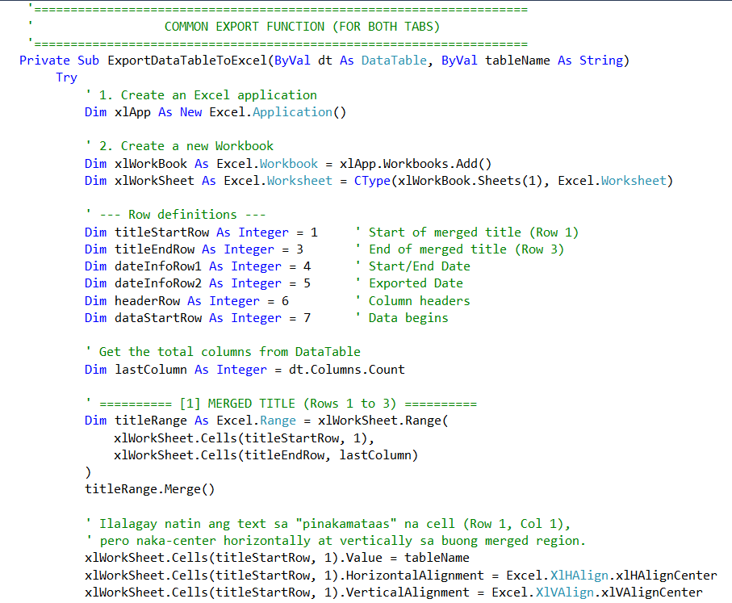

**Image 8. Export Report**

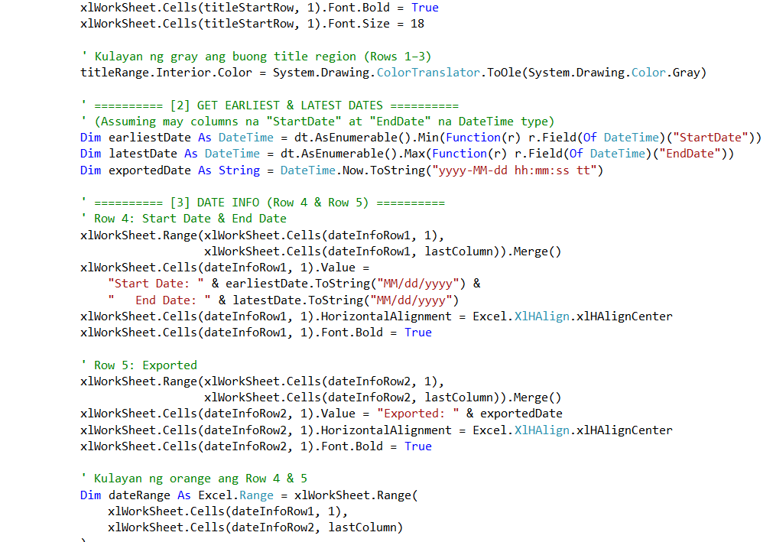

**Image 9. Export Report**

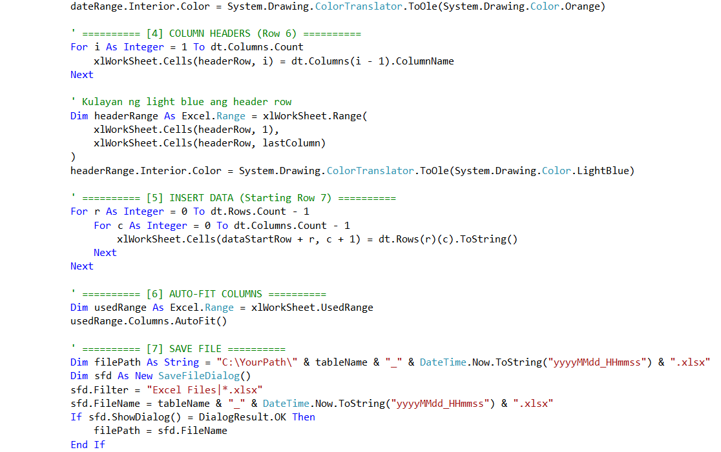

**Image 10. Export Report**

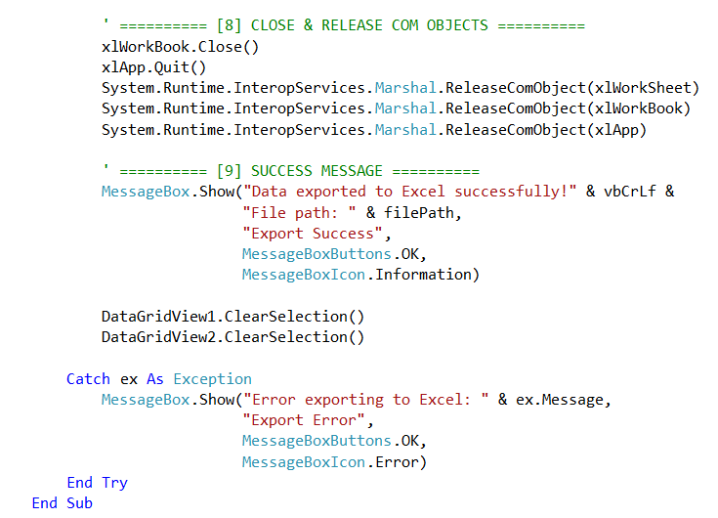

**Image 11. Export Report**

**Explanation and Functionality**

1. **Select Rows.** The user selects one or multiple rows from the table.
2. **Click Export Button.** The user clicks the Export button to initiate the process.
3. **Retrieve Selected Data.** The system fetches the data of the selected rows from the database or table.
4. **Choose File Location.** The user is prompted to select the destination folder and file name.
5. **Export Data.** The system converts the data into a specific file format which is Excel, and saves it.
6. **Completion Message.** A confirmation message is displayed once the export is successful.

**Recycle Bin**

The Recycle Bin is a dedicated table that stores deleted data, allowing user to conserve and retrieve information whenever needed. Instead of permanently deleting records, they are moved to the Recycle Bin table, where they can be restored or permanently removed if necessary.

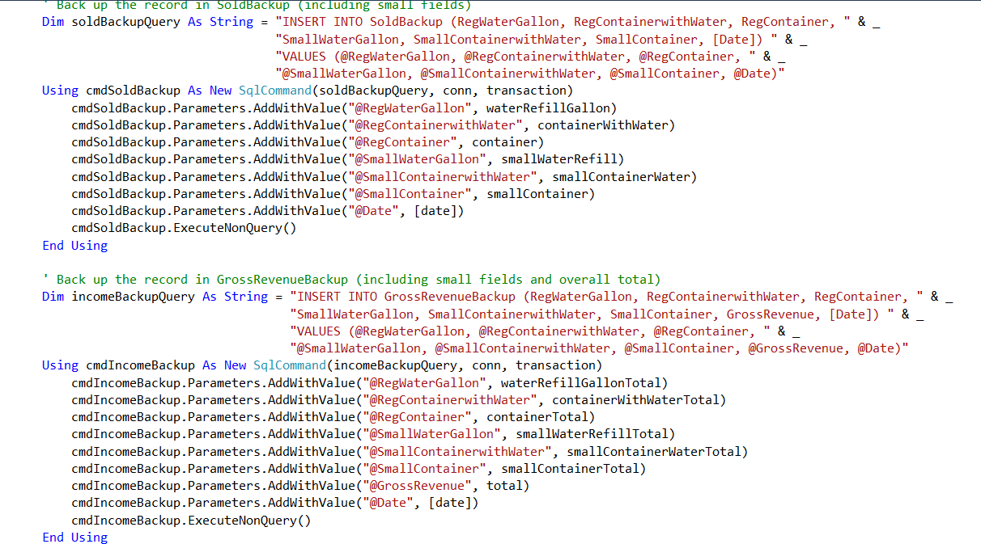

**Image 12. Delete and Conserve to Backup Tables**

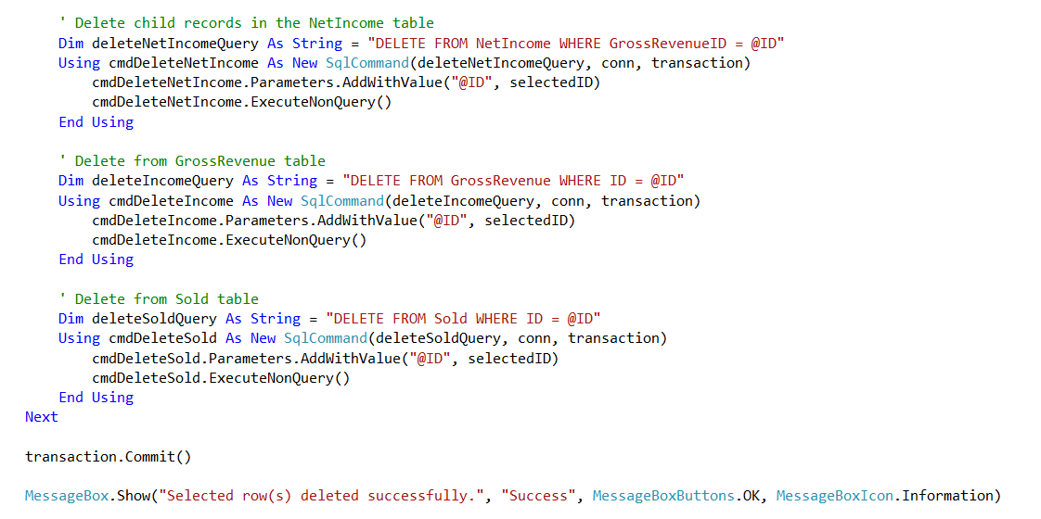

**Image 12. Delete and Conserve to Backup Tables**

**Explanation and Functionality**

1. **Delete Record.** When a record is deleted, it is moved to the Recycle Bin table instead of being permanently removed.
2. **Store Deleted Data.** The system saves all relevant information in the Recycle Bin table, including a Deleted Date timestamp.
3. **View Recycle Bin**. The user can access the Recycle Bin to see a list of deleted records.
4. **Restore Data (Optional)**. The user can select a record and click Restore, moving it back to its original table.
5. **Permanent Deletion (Optional)**. The user can choose to permanently delete a record, removing it from the database.

**TESTING DOCUMENTATION**

In this section, we demonstrate the examination of the Sales and Employee System for AU Water Refilling Station and ensure that every one of its functions are operational. Prior to its actual rollout, a system is subjected to alpha, beta, stress and pen testing which essentially puts the system under real life scenarios to determine its overall usability, performance, and functionality.

**Objectives**

These are the objectives in conducting a system testing, it is to ensure to check every functionality in the system without overlooking things.

1. Ensure all features and functionalities work as intended based on the system’s requirements.
2. Identify defects, inconsistencies, and errors in the system before deployment.
3. Confirm that the system performs well under different conditions without crashing or producing unexpected results.
4. Ensure that the system meets the needs and expectations of users.
5. Verify that data is processed, stored, and retrieved correctly without corruption or loss.
6. Assess the system’s user interface and overall user experience for ease of use.

**Strategies**

These are the testing strategy of the development team conducted; it was performed thorough the development of the system.

1. Alpha Testing. The project team especially the software engineer and system analyst check the system thorough its development.
2. Beta Testing. Allowing other users to try and test the system and ask for feedback, and suggestions for the development team updates.
3. Stress Testing. Pushing the system to its limit, it is a type of trying to work the inappropriate way in a function, form and buttons to see if there are overlooked things that needs to fix.
4. Penetration Testing. This is regarding the security, it is trying to guess and keep on trying to login to the system. This test ensures the functionality of security if it really works well.

**Test Cases**

|  |  |  |  |  |  |  |
| --- | --- | --- | --- | --- | --- | --- |
| Test Case ID | Test Description | Test Steps | Expected Output | Actual Output | Status | Remarks |
| TC001 | Login with valid credentials | 1. Enter username 2. Enter password 3. Click Login | User is redirected to dashboard | User is redirected to dashboard | Pass | N/A |
| TC002 | Login with invalid passwords | 1. Enter username 2. Enter incorrect password 3. Click Login | Error message appears | Error message appears | Pass | N/A |
| TC003 | Adding new employee information | 1. Enter full name 2. Enter Contact number 3. Address 4. Choose date 5. Click Submit | A message showing that adding new employee is successful | A message showing that adding new employee is successful | Pass | N/A |
| TC004 | Updating employee information | 1. Retrieve information from table records 2. Choose and enter the update data | Message showing that updating employee is successful | Message showing that updating employee is successful | Pass | N/A |

|  |  |  |  |  |  |  |
| --- | --- | --- | --- | --- | --- | --- |
| TC005 | Deleting new employee | 1. Retrieve information from table records 2. Click Delete | Confirmation message showing if the user is sure in deleting the employee information | Confirmation message showing if the user is sure in deleting the employee information | Pass | N/A |
| TC006 | Adding new sold gallons | 1. Enter regular water gallon 2. Enter Container with water 3. Enter regular container sold 4. Enter small water gallon 5. Enter small Container with water 6. Enter small container sold 7. Click Submit | Show message that adding new sales is successful | Show message that adding new sales is successful | Pass | N/A |
| TC007 | Updating sold gallons | 1. Retrieve information from table records 2. Choose and enter the update data 3. Click Update | message showing that updating sold data is successful | message showing that updating sold data is successful | Pass | N/A |

|  |  |  |  |  |  |  |
| --- | --- | --- | --- | --- | --- | --- |
| TC008 | Deleting sold gallons | 1. Retrieve information from table records 2. Click Delete | Confirmation message showing if the user is sure in deleting the sold information | Confirmation message showing if the user is sure in deleting the sold information | Pass | N/A |
| TC009 | Generating Sold Reports | 1. Select at least two rows from table records 2. Click generate report | message showing that the user is requesting for report for chosen date in the chosen rows | message showing that the user is requesting for report for chosen date in the chosen rows | Pass | N/A |
| TC010 | Inputting salary for employee | 1. Choose the Full name of employee 2. Choose date of sales 3. Enter Quantity 4. Click Submit | Show message that recording the sales of an employee is successful | Show message that recording the sales of an employee is successful | Pass | N/A |
| TC011 | Updating salary for employee | 1. Retrieve information from table records 2. Choose and enter the update data | message showing that updating the data is successful | message showing that updating the data is successful | Pass | N/A |

|  |  |  |  |  |  |  |
| --- | --- | --- | --- | --- | --- | --- |
| TC012 | Deleting salary of employee | 1. Retrieve information from table records 2. Click Delete | Confirmation message showing if the user is sure in deleting the salary of employee | Confirmation message showing if the user is sure in deleting the salary of employee | Pass | N/A |
| TC013 | Generating Salary Reports | 1. Select at least two rows from table records 2. Click generate report | message showing that the user is requesting for report for chosen date in the chosen rows | message showing that the user is requesting for report for chosen date in the chosen rows | Pass | N/A |
| TC014 | Recording the monthly expenses | 1. Enter Electricity Bill 2. Enter Water Bill 3. Water filter 4. Date 5. Click Submit | message showing that recording the expenses is successful | message showing that recording the expenses is successful | Pass | N/A |
| TC015 | Updating the monthly expenses | 1. Select row from the record table 2. Choose and enter the updated data 3. Click Update | message showing that updating the record data is successful | message showing that updating the record data is successful | Pass | N/A |

|  |  |  |  |  |  |  |
| --- | --- | --- | --- | --- | --- | --- |
| TC016 | Deleting the monthly expenses | 1. Select row from the record table 2. Click Delete | Confirmation message showing if the user is sure in deleting the record of expenses | Confirmation message showing if the user is sure in deleting the record of expenses | Pass | N/A |
| TC017 | Exporting Gross Revenue Report | 1. Select row from the record table 2. Click Export Record | A file manager windows shows and can choose where to save the exported report | A file manager windows shows and can choose where to save the exported report | Pass | N/A |
| TC018 | Exporting Salary Report | 1. Select row from the record table 2. Click Export Record | A file manager windows shows and can choose where to save the exported report | A file manager windows shows and can choose where to save the exported report | Pass | N/A |
| TC019 | Restore sold record | 1. Select row from the record table 2. Click Restore | A message will show saying that the restoration of record is successful | A message will show saying that the restoration of record is successful | Pass | N/A |

|  |  |  |  |  |  |  |
| --- | --- | --- | --- | --- | --- | --- |
| TC020 | Permanently deleting sold record | 1. Select row from the record table 2. Click Delete | Confirmation message showing if the user is sure in permanently deleting the record of sales | Confirmation message showing if the user is sure in permanently deleting the record of sales | Pass | N/A |
| TC021 | Restore gross revenue report record | 1. Select row from the record table 2. Click Restore | A message will show saying that the restoration of record is successful | A message will show saying that the restoration of record is successful | Pass | N/A |
| TC022 | Permanently deleting gross revenue report record | 1. Select row from the record table 2. Click Delete | Confirmation message showing if the user is sure in permanently deleting the record of gross revenue report | Confirmation message showing if the user is sure in permanently deleting the record of gross revenue report | Pass | N/A |
| TC023 | Restore employee salary record | 1. Select row from the record table 2. Click Restore | A message will show saying that the restoration of record is successful | A message will show saying that the restoration of record is successful | Pass | N/A |

|  |  |  |  |  |  |  |
| --- | --- | --- | --- | --- | --- | --- |
| TC024 | Permanently deleting employee salary record | 1. Select row from the record table 2. Click Delete | Confirmation message showing if the user is sure in permanently deleting the record employee salary report | Confirmation message showing if the user is sure in permanently deleting the record employee salary report | Pass | N/A |
| TC025 | Restore employee information record | 1. Select row from the record table 2. Click Restore | A message will show saying that the restoration of record is successful | A message will show saying that the restoration of record is successful | Pass | N/A |
| TC026 | Permanently deleting employee information record | 1. Select row from the record table 2. Click Delete | Confirmation message showing if the user is sure in permanently deleting the record employee information | Confirmation message showing if the user is sure in permanently deleting the record employee information | Pass | N/A |
| TC027 | Restore bills record | 1. Select row from the record table 2. Click Restore | A message will show saying that the restoration of record is successful | A message will show saying that the restoration of record is successful | Pass | N/A |

|  |  |  |  |  |  |  |
| --- | --- | --- | --- | --- | --- | --- |
| TC028 | Permanently deleting bills record | 1. Select row from the record table 2. Click Delete | Confirmation message showing if the user is sure in permanently deleting the record of the bills | Confirmation message showing if the user is sure in permanently deleting the record of the bills | Pass | N/A |
| TC029 | Logging out | 1. Click Logout | Confirmation message showing if the user is sure on logging out | Confirmation message showing if the user is sure on logging out | Pass | N/A |

**Test Results**

These are the results for testing using the strategies that has been conducted to the system.

**Alpha Testing**

During the alpha testing phase, the development team conducted a thorough analysis of the system’s contents before proceeding with additional functionalities. Each form was reviewed to ensure that the gathered data was correctly integrated into the developed system. Various issues, including glitches, bugs, and runtime errors, were encountered during testing. Upon identifying these issues, detailed feedback was documented and provided to the developers for necessary improvements. This process ensures that the system is stable, functional, and effective before deployment, minimizing potential issues and enhancing usability.

**Beta Testing**

During the beta testing phase, users employed various methods to evaluate the system, including reviewing each form to ensure all functionalities operated according to the intended workflow. In performance testing, users tested forms individually to assess system quality and determine if it met their expectations. For security testing, users entered data to identify potential errors during runtime. After submitting user inputs, they verified the database tables to confirm that the data was correctly recorded. Additionally, security features were assessed to determine whether the system effectively met user requirements.

**Stress Testing**

Stress testing evaluates the system’s ability to handle extreme conditions by pushing it beyond its normal operational limits. In this testing phase, students intentionally attempt to overload the system by entering excessive data, using special characters, symbols, and other unconventional inputs. The goal is to determine if the system can maintain stability under high-stress conditions and identify any vulnerabilities that may cause it to fail.

**Stress Test Results**

During the stress test, students encountered errors when the system reached its input limit for quantity. As a result, the system began to malfunction and eventually crashed. These unexpected issues were not identified in previous testing phases, highlighting areas that require improvement to enhance system stability and prevent failures under extreme usage conditions.

**Penetration Testing**

During the penetration testing, which the development team forced to try multiple attempts of login it repeatedly shows the error messages and not abled to bypass the security of login of the system.

**MAINTENANCE GUIDE**

In this phase the development team provide a procedure to guide when maintenance occur in the system.

**Step 1.** Mandatory to seek an update of the system after a week of being deployed, to ensure of getting the feedback of the client and to ensure of fixing of possible bugs occur by the user.

**Step 2.** Check for new software updates for the system and whether it will help the system or not. Within 2 months it can be checked for software updates for the system, not weekly, because the operations of the system will be interrupted. It's better if it's every 2 months.

**Step 3:** When the system has major updates or major maintenance of the software, it is necessary to always have backups to transfer important documents and files that may be affected when a major update or major maintenance of the software is performed and make sure that after the update or maintenance, all files can be restored and documents transferred from the backup back to the new updated system.

**Step 4:** Within 2 months, check the availability updates for the system software. Understand new software updates in terms of what good they can do to the system or how they can help protect your system.

**Step 5:** Now you have updated the software of the system, testing it to see whether it is compatible with the system or your software when you updated it. While testing it, the new update in software should fix the simple bugs that affect the performance of your system, and above all, only update what is needed; if it is not necessary, don't update it so that there will be no impact on the performance of the system.

**Step 6:** Give a plan to the user of the system when the system software will be maintained, also shutdown applications that may have an impact while updating the system software. Official tools or apps can also be used to install software updates.